CPSC 4110

Course Project

### **Taylor Doud, Jordan Pickett, Matthew Rose**

## Intro

In this project, we will be developing a program to simulate multiple different quantum algorithms using a classical binary computer system. The quantum algorithms we will be seeking to create are the Controlled-NOT gate, Toffoli gate and Deutsch's algorithm.

## Algorithm summary

### Controlled-NOT

Controlled-NOT gate is used to entangle and disentangle Quantum states. Due to its inherent nature, CNOT can be used to simulate any other quantum circuit and is a required structure for many other quantum gates. It operates using 2 qubits and its quantum register is represented as such:

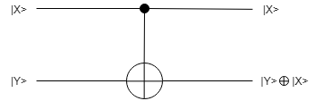

### Tofolli Gate (CCNOT)

The Tofolli Gate is a universal reversible gate that can be used to recreate any other logic gate. It operates using 3 qubits and its quantum register is represented as such:

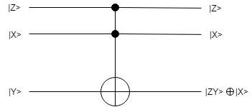

### Deutsch’s Algorithm

Deutsch's Algorithm isn’t a gate but a practical application of quantum computing that is used to display a situation where quantum computing is more accurate then classical computing. It operates using 2 qubits and it quantum register is represented as such:

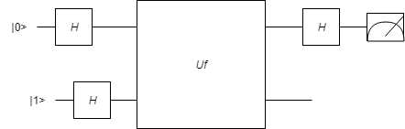

**Important Data Structures**

complex<double>

We use this data structure to contain complex numbers. This data type allows us to access the real and imaginary portions of a complex number by calling their appropriate function calls.

vector<complex<double>>

This data structure allows us to store a vector of complex<double> allowing use to perform functions such as vector addition and multiplication.

vector<vector<complex<double>>>

We use this data structure to store a vector<complex<double>> inside a vector. This allows us to create a complex 2D matrix to solve quantum equations.

### What did we learn?

We learnt how difficult it can be to implement these algorithms as we had to deal with lots of 2D matrices and their multiplication. We realized the limitation of classical computers when trying to simulate these quantum algorithms.

### Improvements?

* Include a GUI to better represent the quantum circuits and matrices.
* Implement an observable function as well as a orbit function
* Bra Ket notation for displaying qubits
* More error handling
* Non-hardcoded portions of functions
* Better documentation

## Issues?

We only every really had a single issue while developing these algorithms. Calculating Uf matrix proved to be fairly difficult as we didn’t want to use binary addition.